IFT 266 Introduction to Network Information Communication Technology (ICT)
Lab 20
Classless Subnetting – Down and Across
Co-authored by Mallory Dodds

Note: Periods between octet values will take up a box

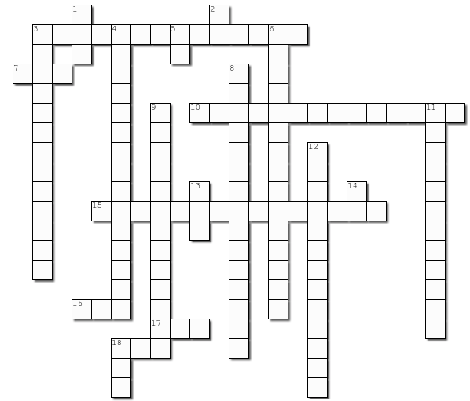

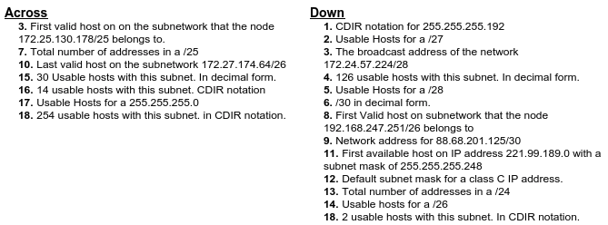
Across
1. 172.25.130.1
2. 128
3. 172.27.174.126
4. /27
5. /28
6. 254
7. /24

Down
- /26 7. 88.68.201.0
- 30 8. 221.99.189.1
- /25 9. 255.255.255.0
- 14 10. 256
5. 30 11. 62
6. 192.168.247.1

